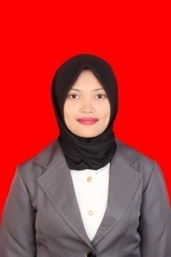

**Erliyanti Asri Kusumah**

Cianjur, 10 Agustus 1994

Kp. Benda Rt.01 Rw.07 Ds. Sukataris

Kec. Karangtengah Kab. Cianjur 43281

+6282318040560

[asrikusumah@gmail.com](mailto:asrikusumah@gmail.com)

**Qualifications Summary**

Computer Ms. Word, Ms. Power Point, Ms. Excel and

Statistical Product and Service Solution (SPSS)

Language Good in English both oral or writing

Fluent in Bahasa both oral or writing

Communication Good to listen, persuade, and consult

Orgnisational Assume responsibility

Careful

Able to work independent or in a team

Highly motivation to work

Information Good to manage information

Good analytical the information

Physical IT skills and repair

Interpersonal Counsel/Advice

Investigation and

Research Evaluate

Design and Planning Anticipates problems

**Education**

**Jenderal Achmad Yani University, Cimahi**

Degree S.IP, Government Science (GPA: 3,77) September 2016

Supporting Education Computer Broad Base Education Life Skill Program Education

Interactive Discussion with State Secretariat Ministry Republic of

Indonesia

Interactive Discussion with Ombudsman Republic of Indonesia

Seminars of Entrepreneurship and Nationality

Capital Markets School in Indonesia Stock Exchange

The Career Development Workshop Job and Internship Guide

Research The Impact of Segregation Village to Administration Service

Quality at Sindangsari Village Kadupandak Sub-District in

Cianjur Regency

**Skills and Accomplishment**

**Data Analysis**

Conduct and use statistical modeling technique to analyze the data in research

**Teamwork and Interpersonal Skills**

Mentored the students accounting major for religious assistant program

Conceptualize research on Government students major practice of Jenderal Achmad Yani

University about tourism economy development

Conceptualize and lead a business in entreupreneurial activity

**Organization and Administrative Skills**

Recap team scores on rules marching contest of Jenderal Achmad Yani University FISIP

Championship

Execute tasks with minimal to no supervision while producing detail-oriented and accurate

Work

**Experience**

Data recaps electricity prepaid and postpaid subscribers all of rayon in Cianjur at PT PLN

Cianjur area